- In Workday, select “Request Travel or Purchase”.
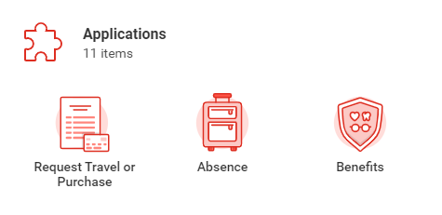
- Select “Request to Procure Goods and/or Services”.
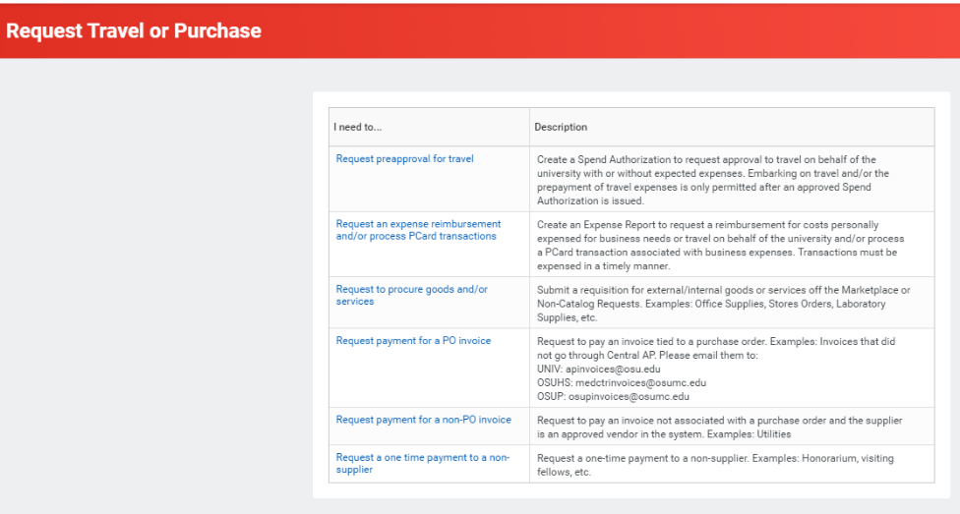
- Fill in your Name/Worktags (should mostly auto-populate).
Select “Non-catalog”.
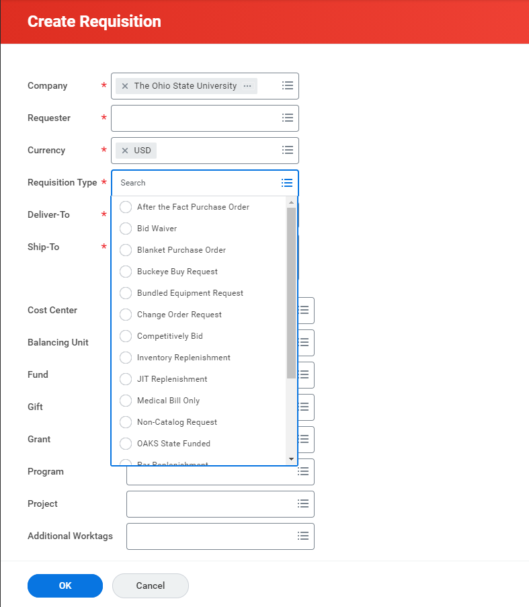
- Choose Chem Instrument Support Group in the supplier search box.
(Tip: type “chem” then press enter).
Include copious notes describing your request in Item description and Memo fields.
Required information: Nature of problem, Mfg., Model, Serial Number, OSU asset #, etc.
Be sure to include your name and email address, Group/Prof. name, and department.

